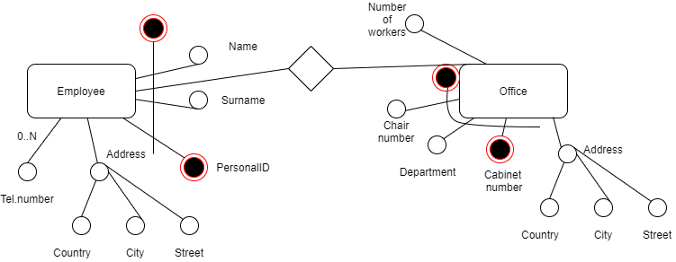

Entity

Employee(personalID,name, surname, country, city, street)

Office(department, cabinet number, chair number, country, city, street, number of workers)

Relationship

Work(employee, department, cabinet number, chair number)

DROP TABLE IF EXISTS Employees,Office,Work,tel_numbers_of_employees CASCADE;

CREATE TABLE Employees (

personalID INTEGER PRIMARY KEY,

name VARCHAR(100) NOT NULL,

surname VARCHAR(100) NOT NULL,

country VARCHAR(100) NOT NULL,

city VARCHAR(100) NOT NULL,

street VARCHAR(100) NOT NULL,

UNIQUE(name, surname, country, city, street)

);

CREATE TABLE Tel_numbers_of_employees (

number CHAR(9) NOT NULL,

employee INTEGER,

PRIMARY KEY(number, employee),

CONSTRAINT employees_number FOREIGN KEY (employee) REFERENCES Employees (personalID),

CONSTRAINT ch_tel_number CHECK (number not like '%[^0-9]%')

);

CREATE TABLE Office (

department INTEGER,

chair_number INTEGER,

cabinet_number INTEGER,

PRIMARY KEY(department,chair_number,cabinet_number),

country VARCHAR(100) NOT NULL,

city VARCHAR(100) NOT NULL,

street VARCHAR(100) NOT NULL,

number_of_workers INTEGER

);

CREATE TABLE Work (

employee INTEGER,

department INTEGER,

cabinet_number INTEGER,

chair_number INTEGER,

PRIMARY KEY(employee,department,cabinet_number,chair_number),

CONSTRAINT employee_id FOREIGN KEY (employee) REFERENCES Employees (personalID),

CONSTRAINT office_info FOREIGN KEY (department,cabinet_number,chair_number) REFERENCES Office (department,cabinet_number,chair_number)

);